Corpus Christi Parish, Mass at St. Paul VI High School

- Entrance to Property and Parking
- Address: 42341 Braddock Road, Chantilly, VA 20152

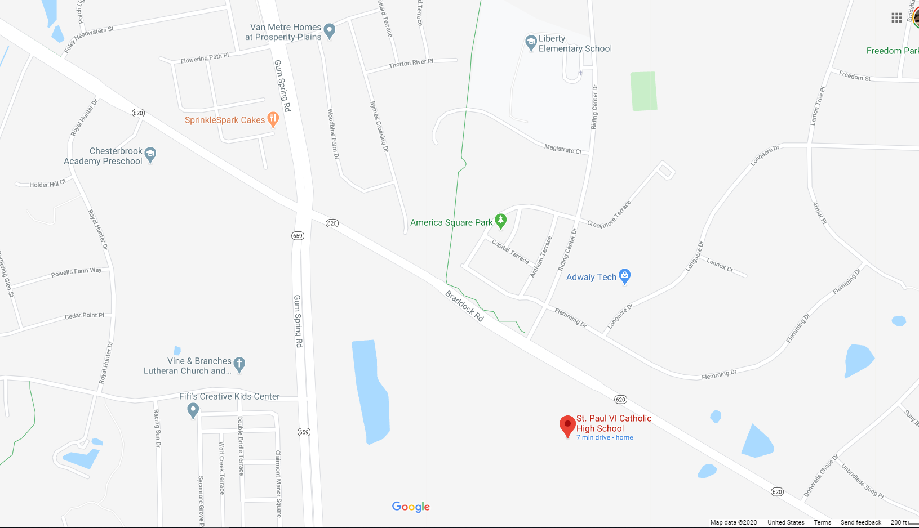

- Here is a sample video on how to get there. Direction is coming from Northstar Blvd where John Champe is.

https://youtu.be/6iZI-5qB64c

- Entrance to building from the parking lot. Follow signs, ushers and volunteers.

https://youtu.be/JP-uEaMvM-s

- Entrance to Auditorium

Upon entering the building, immediately turn to your left and walk straight following the hallway. The entrance to the auditorium will be on your right.

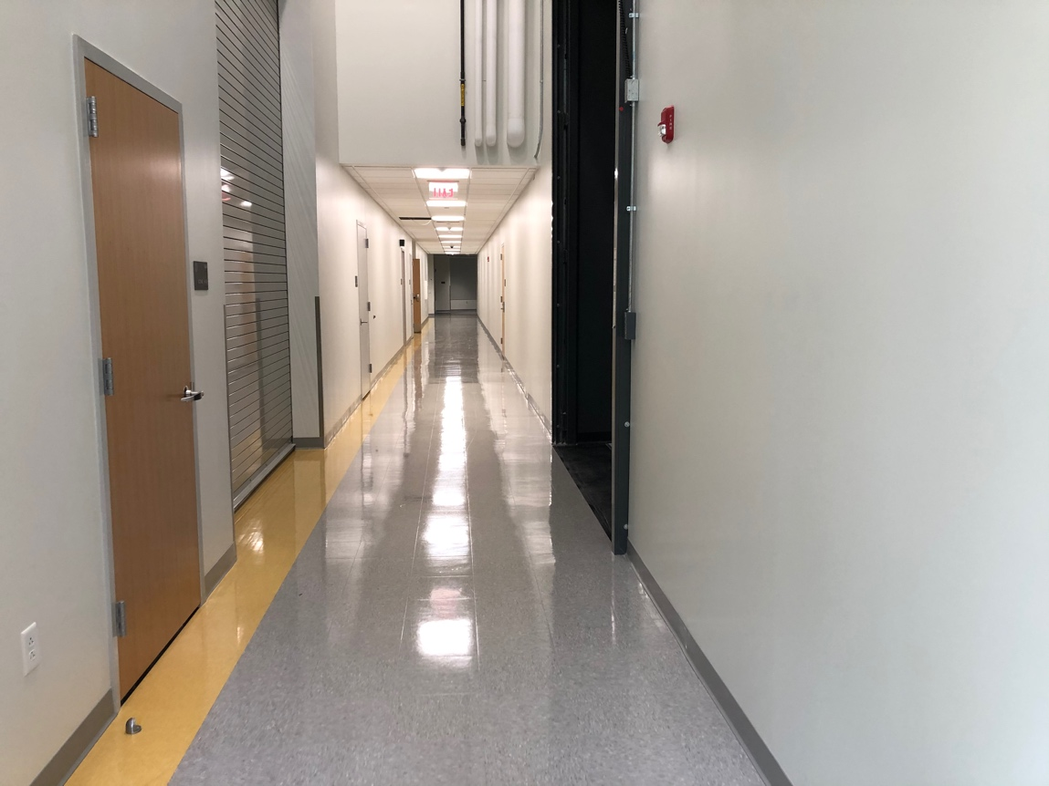

- Seating

In order to be fully compliant with the diocesan guideline, alternate rows have been marked/blocked using blue (painter’s) tape.

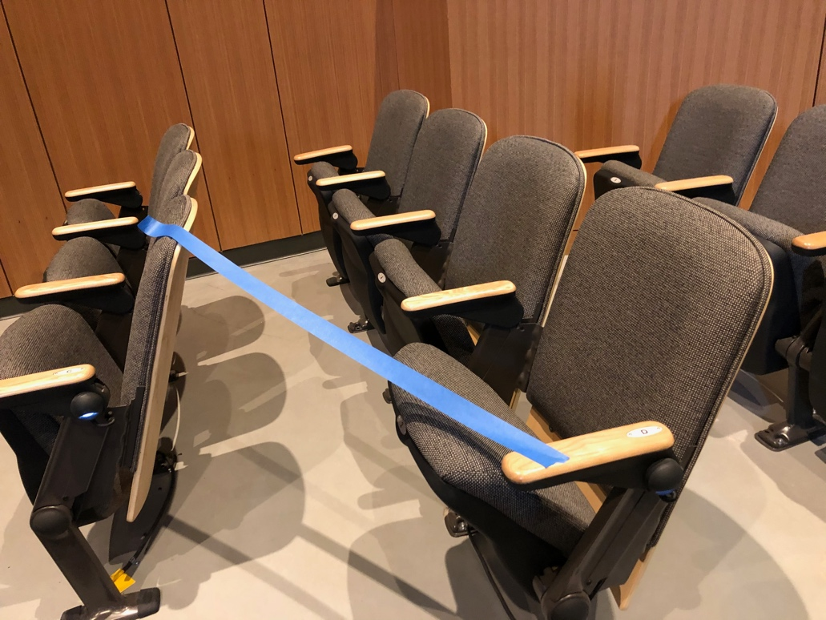

Families living in the same household can sit together consecutively (please do not leave an empty chair in between family member as we have limited seating capacity). 4 areas have been designated for parishioners to sit. See diagram below.

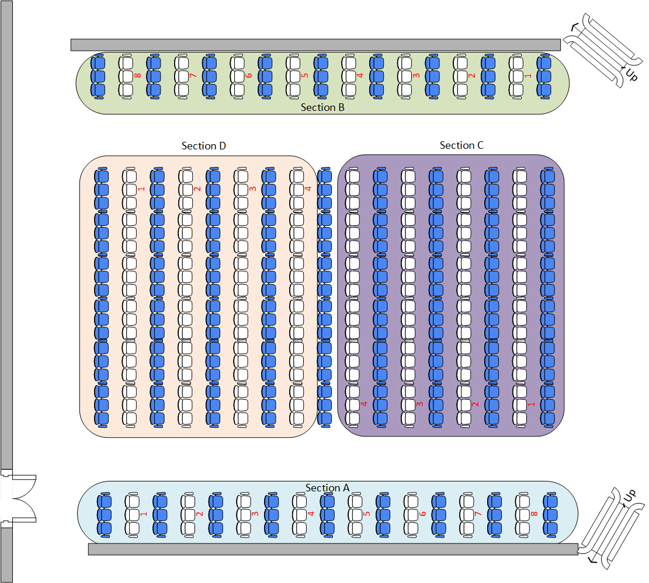
S T A G E

- Blue rows are blocked and should be vacant
- Reserve front rows especially for sections A & B to handicapped and/or elderly.
- Ushers will be there to guide you.
- There won’t be a processional march.
- No singing
- No holding of hands during the “Our Father”
- No Sign of Peace
- Collection will be at the end of the Mass as you exit the auditorium. Collection baskets are place on top of the table near the entrance door labeled 1st and 2nd collection.

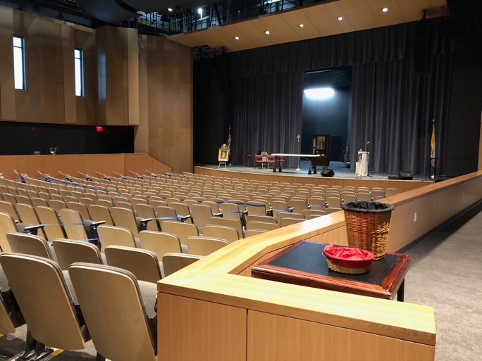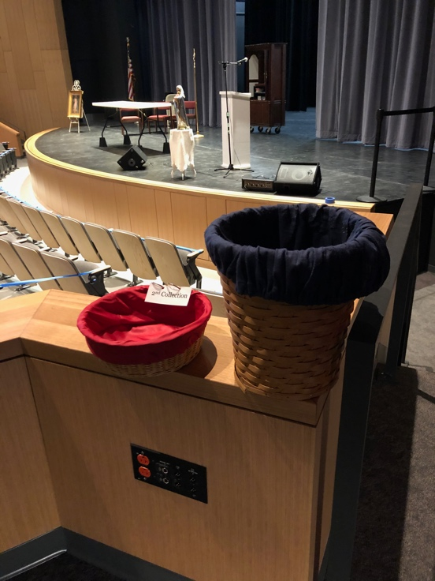

- Holy Communion

Holy Communion can only be given by a priest or deacon. There won’t be any Eucharistic Ministers. Clergy will be using rubbing alcohol to sanitize their hands before, during and after the distribution of Holy Communion. With these factors in mind, please expect a slower flow. Our priest will be strategically stationed 1 at the front right corner near the stair and the other will be at the back, left side of the auditorium. See diagram below.

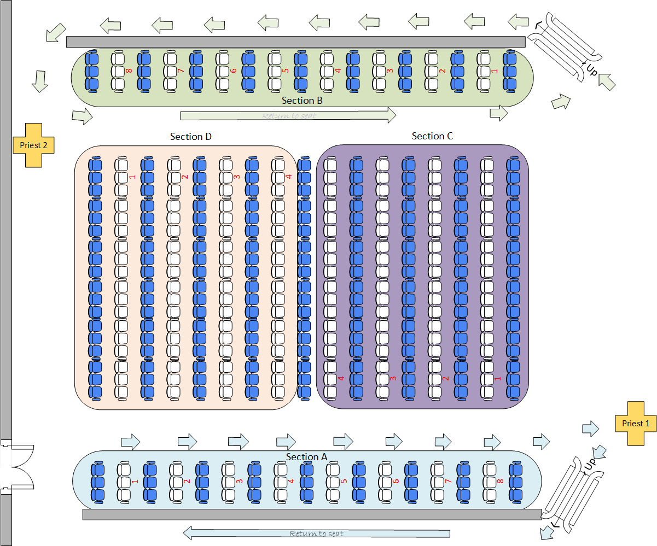

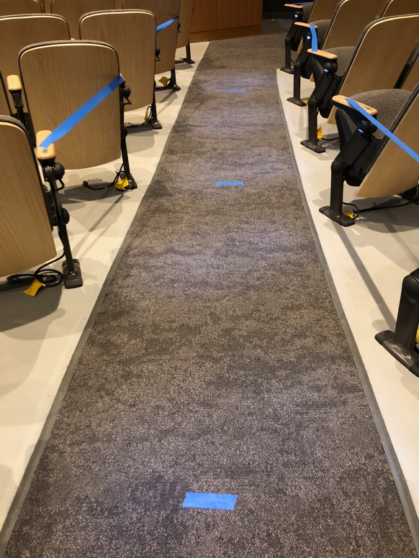

Communion will start with sections A & B. Section A will start from the last row (see diagram, marked with red number). Please maintain 6’ distance from the person in front of you. There will be marks on the floor.

After you have received the Holy Eucharist, walk toward the stairs on your right side, to the ramp on the side and go back to your seat. The idea is moving in a circular flow.

Section B will start with the front row (see diagram, marked with red number), going up to the stairs and through the ramp and receive the Holy Eucharist from priest 2 at the back. Return to seat.

Once section A & B are done, sections C & D will follow. Section C will start with the front row and will receive the Holy Eucharist from priest 1.

Section D will start from the back row and will receive the Holy Eucharist from priest 2. See diagram below.

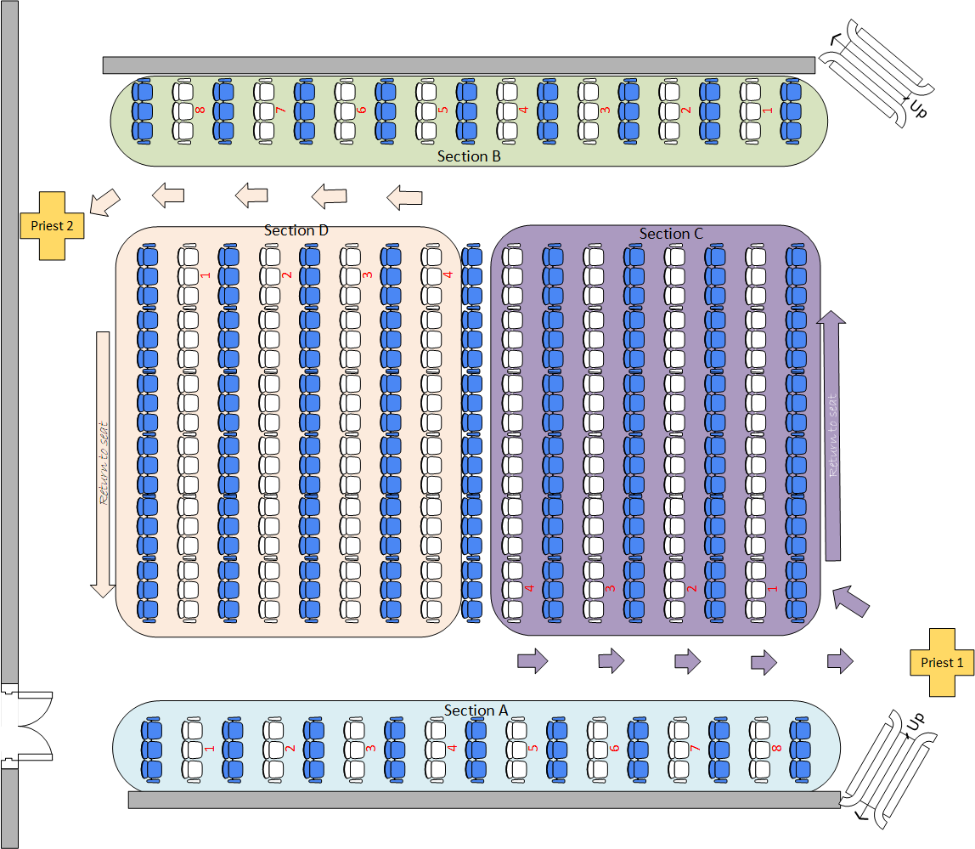

- Exit

At the end of the Mass, you may exit the auditorium either at the door where you entered or take the ramp on the right side of the auditorium and through the side of the stage. Please refrain from congregating at the hallways. You may do so once you are out in the open space in the parking lot.

